***Assignment # 1***

|  |  |
| --- | --- |
| **Name** | Muhammad Asad |
| **Roll #** | 2019-EE-383 |
| **Section** | A-G1 |



***Programming Fundamentals***

**Lab # 1**

* **Objectives:**
* Install the Java IDE.
* Create your first project.
* Print Hello world on the output screen.
* **Task # 1:**

Which is the best IDE for Java and Write the methods to build a class.

* **Answer:**

The best IDE, I found for java programming is “ Net beans”.

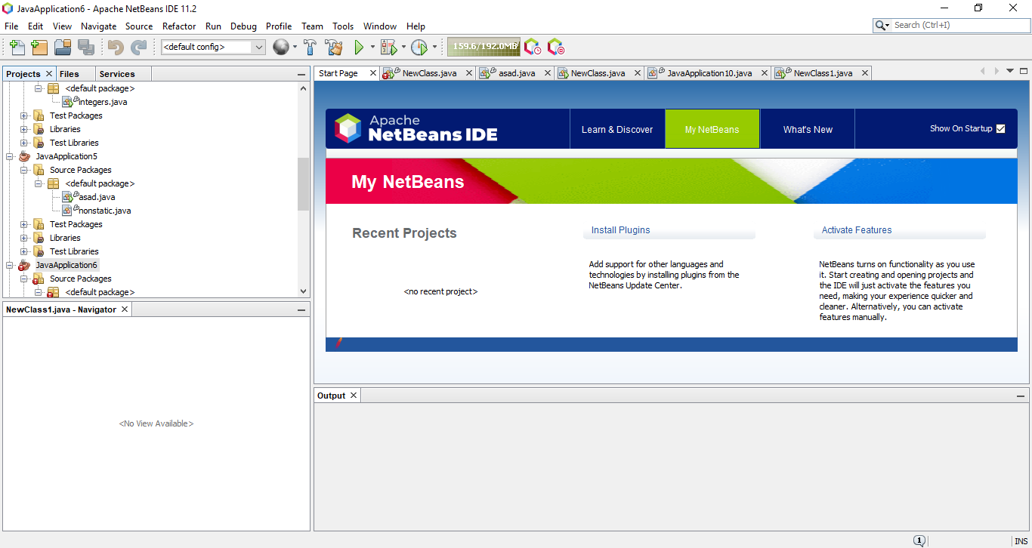

* **The methods to build a class are as follows:**
* **First of all create a new file same as given below:**

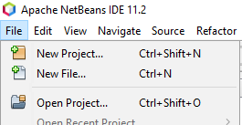

* **Then select the option Java with Ant and Java Application and go Next.**

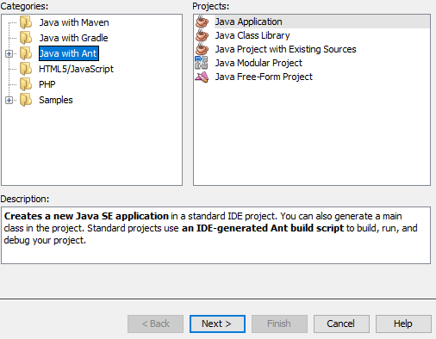

* **Uncheck The tick (Create main Class) and Click Finish.**

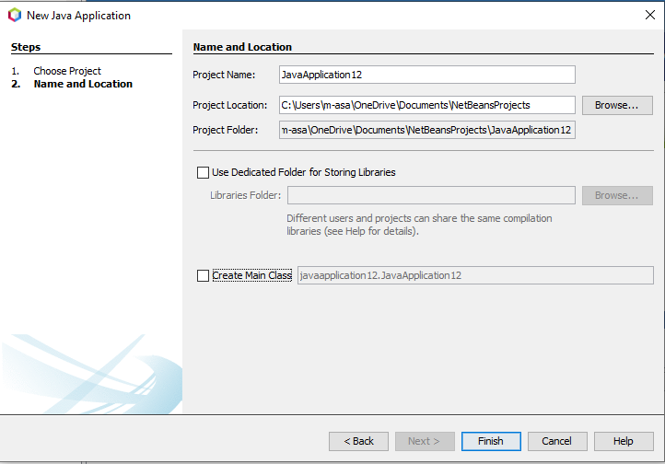

* **This File has been created and then Right click the mouse on source packages.**



* **Click New and Java Class**

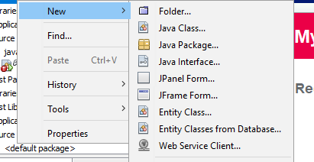

* **Give it a class name and Finish it.**

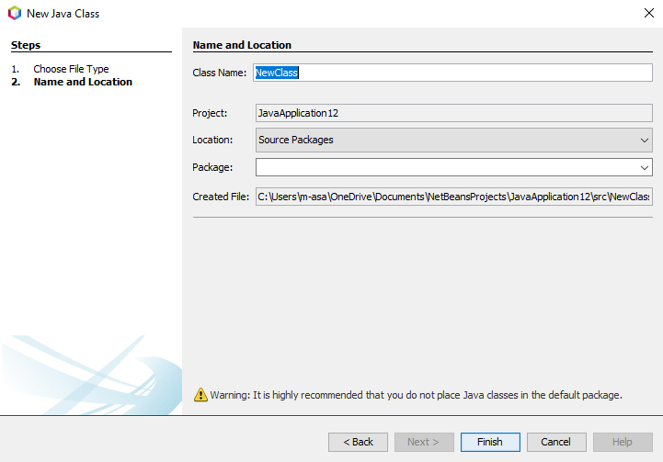

* **Class has been created.**

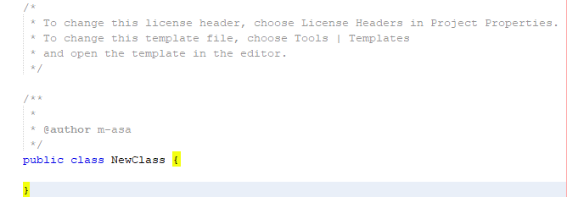

* **Task # 2:**

Write your first class in java IDE and run a program which will display the “Hello World” in the output screen.

* **Code:**

**//** Java is case sensitive

public class NewClass {

//public means that anyone can access it

// void is nothing

//static means not to return to class

//main is the initializer of class.

Public static void main (String[] args){

//This Statement gives result on output screen

//Execution Starts from main method.

System.out.println("Hello World");

}

}

* **Output:**

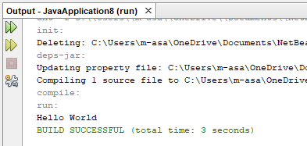

* **Conclusion:**
* In this lab , I learnt To install the Netbeans IDE for Java,

It is one of the best compilers for java

IDE=Integrated development environment

* Install first the JDK java 64 in PC and then Netbeans IDE



* This lab tells us to write a program and taking a String argument to display the output on the output screen.



**High Level Language** **Low Level Language**

A high-level language (HLL) is a programming language such as C, FORTRAN, or Pascal that enables a programmer to write programs that are more or less independent of a particular type of computer. Such languages are considered high-level because they are closer to human languages and further from machine languages.

A low-level programming language is a [programming language](https://en.wikipedia.org/wiki/Programming_language) that provides little or no [abstraction](https://en.wikipedia.org/wiki/Abstraction_(computer_science)) from a computer's [instruction set architecture](https://en.wikipedia.org/wiki/Instruction_set_architecture)—commands or functions in the language map closely to processor instructions. Generally, this refers to either [machine code](https://en.wikipedia.org/wiki/Machine_code) or [assembly language](https://en.wikipedia.org/wiki/Assembly_language). The word "low" refers to the small or nonexistent amount of [abstraction](https://en.wikipedia.org/wiki/Abstraction_(computer_science)) between the language and machine language; because of this, low-level languages are sometimes described as being "close to the hardware".

* **Note:**

Programs written in low-level languages tend to be relatively [non-portable](https://en.wikipedia.org/wiki/Software_portability).

**Python** **Java**

Python is a dynamically-typed general-purpose programming language. Python’s early development began at a research institute in the Netherlands. The original motivation behind it was to create a higher-level language to bridge the gap between C and the shell, as the author states, creating system administration utilities using C back at that time was pretty complicated. The syntax was also motivated by a few languages like Algol68, Pascal, and ABC and was meant to be readable and clean.

Java is a statically typed general-purpose programming language, it is an object-oriented and concurrent language. Java was meant to be WORA (write once run anywhere) language, it was designed to run on any platform and with as few dependencies as possible, with the help of the Java Virtual Machine (JVM).